Active Directory Using Windows Server

# What is an active directory?

Active Directory is Microsoft's trademarked directory service, an integral part of the Windows 2000 architecture. Like other directory services, such as Novell Directory Services (NDS), Active Directory is a centralized and standardized system that automates network management of user data, security, and distributed resources, and enables interoperation with other directories. Active Directory is designed especially for distributed networking environments.

**DESCRIPTION:**

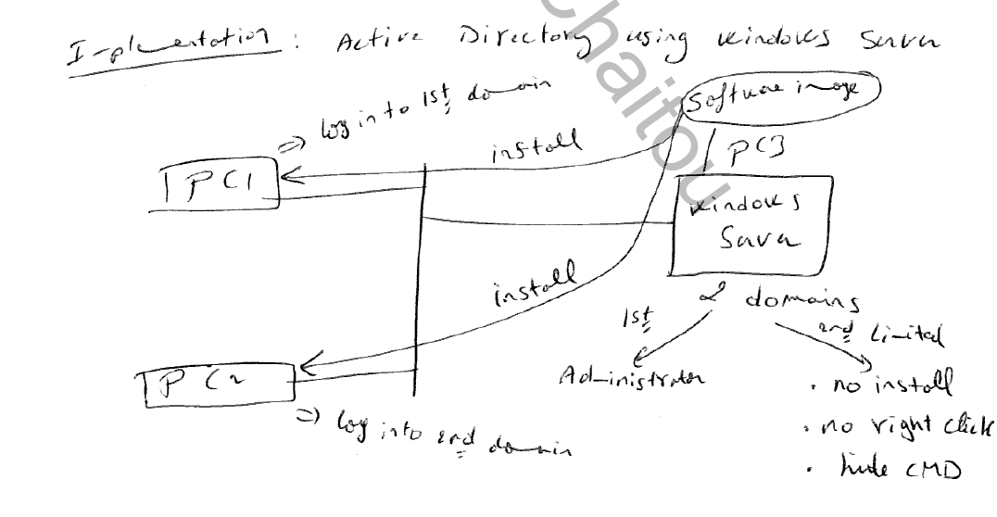

First of all, we create two virtual machines one for PC3 windows server 2008 and the other PC1 for windows 7.  
In PC1 : first we should Install Active directory domain service and set password for it, after running it create an active directory domain we call it internal.example.com.  
After that we create two organization units (OU) one we call it administrator and the other limited user.  
For the first organization unit (administrator)we link it with a group policy object(GPO) named Admin after creating it .Then we repeat the same procedure for limited user OU that we link it to GPO named limit user. But for this GPO there are some actions that the user can’t do. These actions are: no install, no right click and no cmd .  
Finally after linking we create a new user for each organization unit and we set a password for it.

After downloading windows server2008, we have to create an active directory:

1. From the Windows **Start** menu, open **Administrative Tools > Server Manager**
2. In the **Server Summary** section of the Server Manager window, click **View Network Connections**

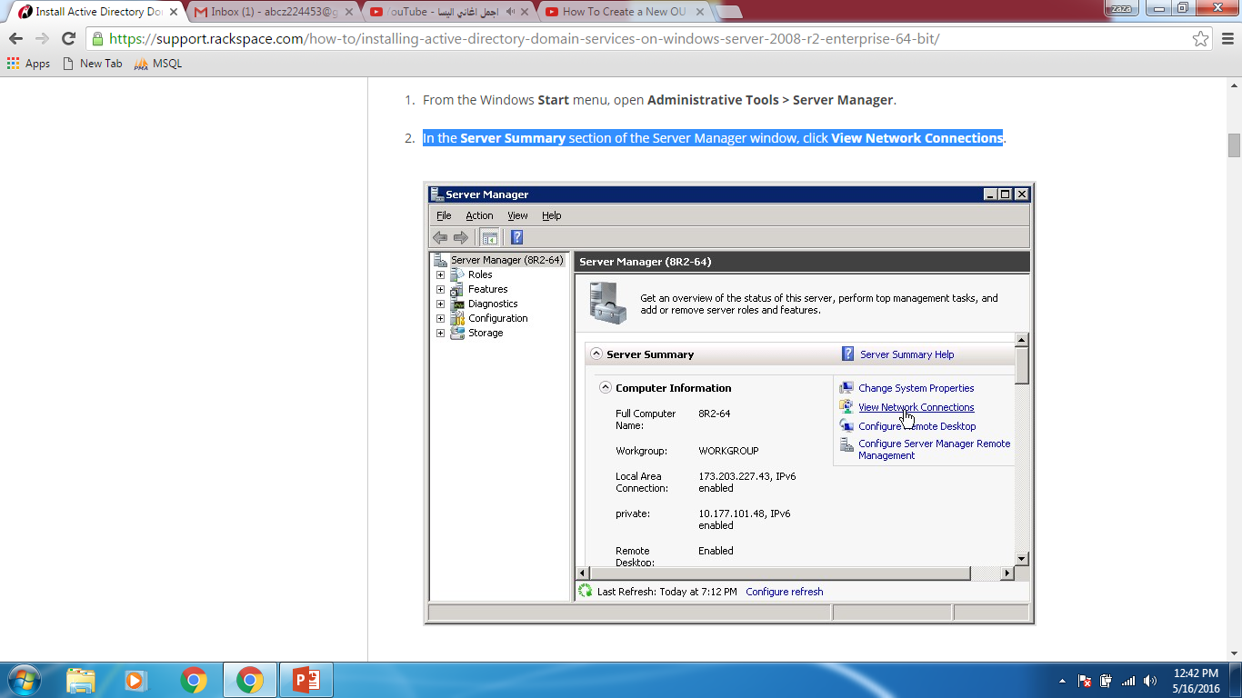

1. **In the Network Connections window, right-click Local Area connection and select Properties.**

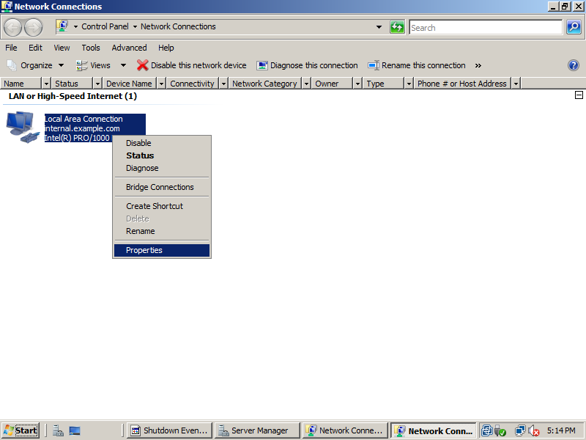

1. **Select Internet Protocol Version 4, and then click Properties.**
2. **Copy the IP address that is displayed in the IP address box and paste it into the Preferred DNS serverbox. Then, click OK.**
3. **Click OK in the Properties dialog box, and close the Network Connections window**

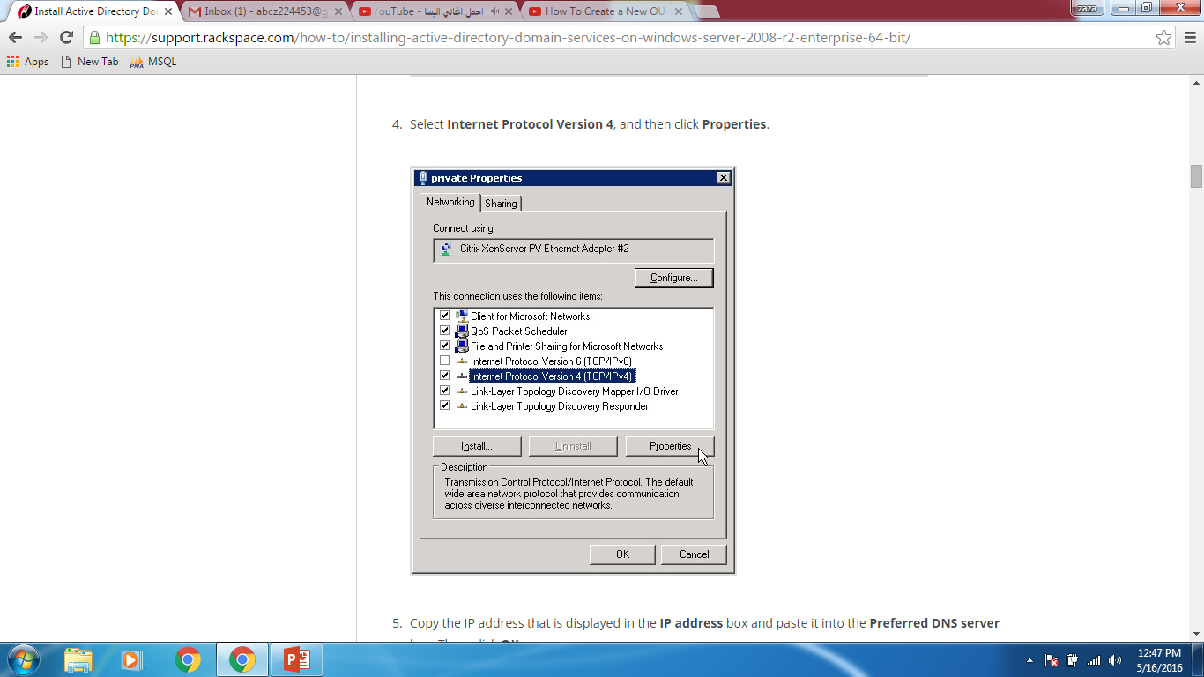

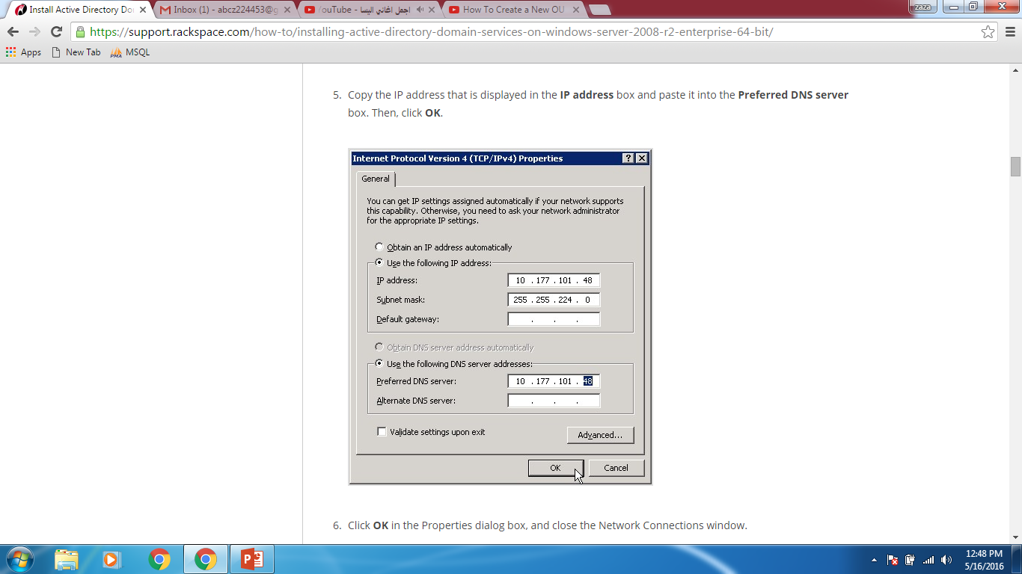

**Add the Active Directory Domain Services Role  
1.** In the Server Manager window, open the Roles directory and in the Roles Summary section, click Add Roles.

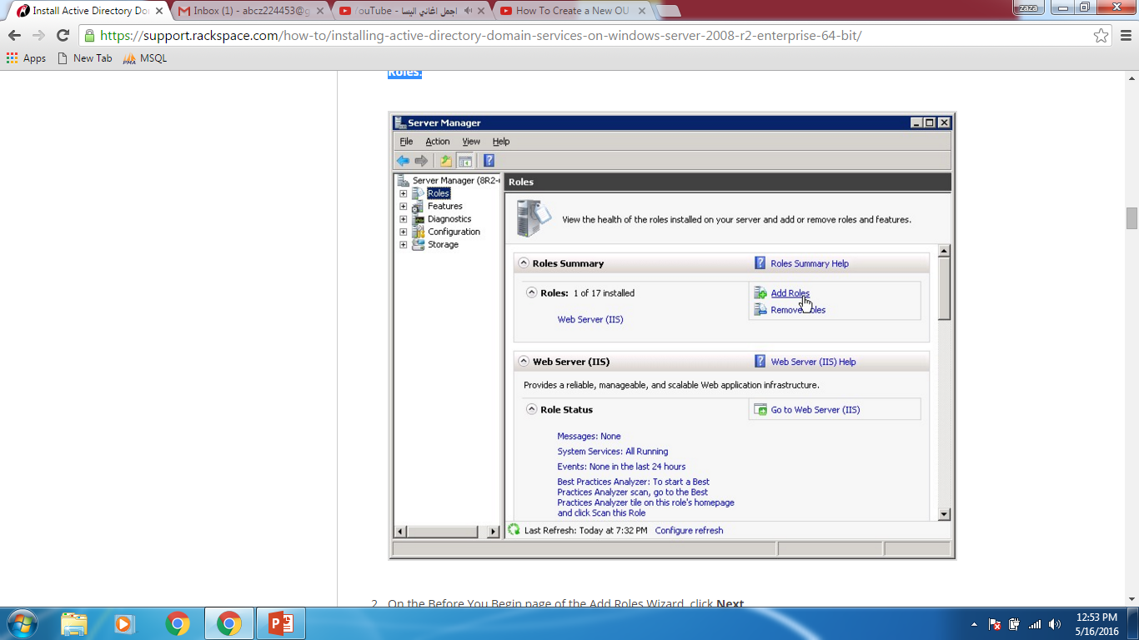

**2.** On the Before You Begin page of the Add Roles Wizard, click Next **3.** On the Select Server Roles page, select the Active Directory Domain Services check box, and then click Next on this page and on the Confirmation page.

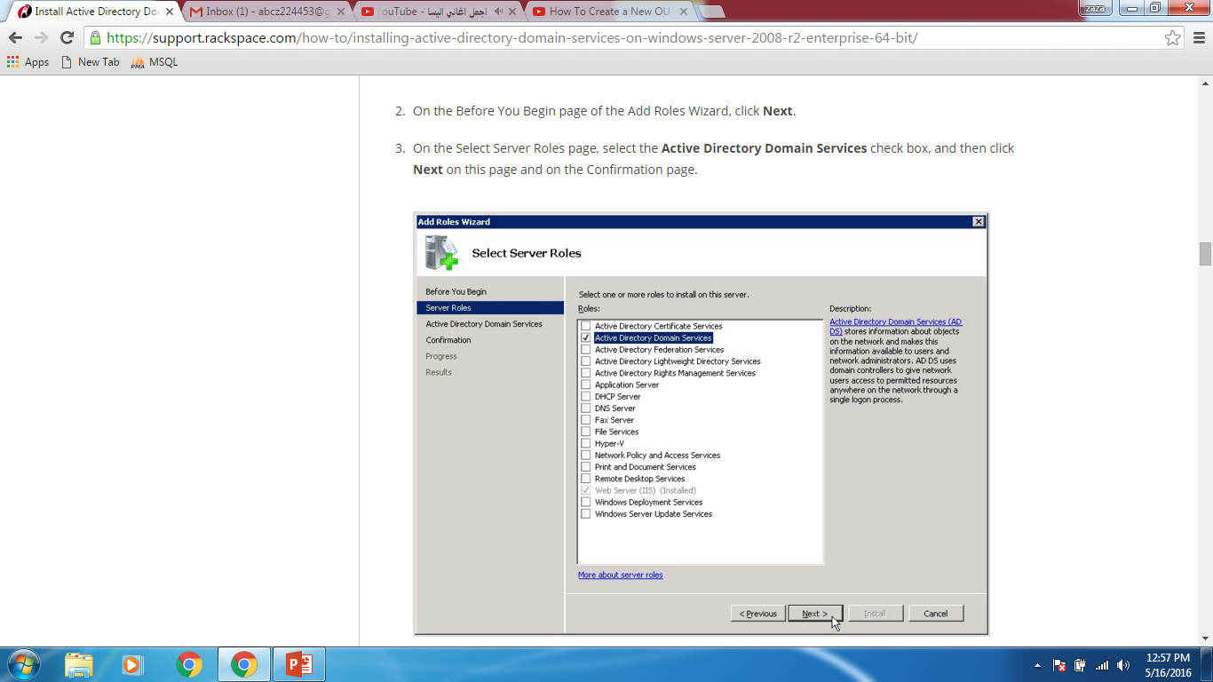

**4.** On the Installation Progress page, click Install

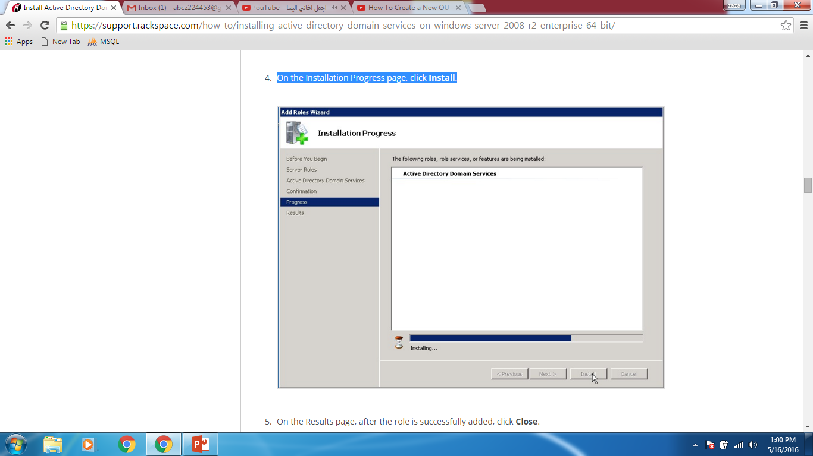

**5**. On the Results page, after the role is successfully added, click **Close**.

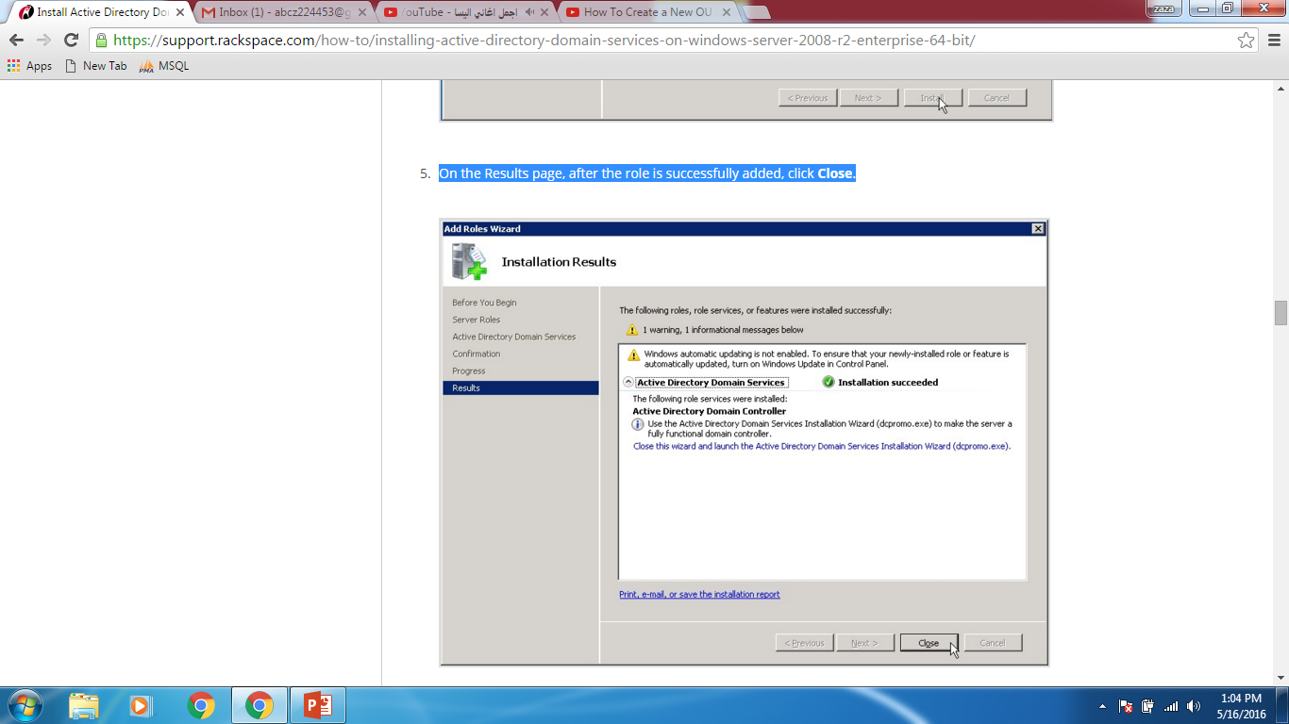

**Enable the Remote Registry  
  
1.**Open the Server Manager window if it is not already open.  
  
2. In the **Properties** area of the **Local Servers** page, click **Remote Management**.  
  
3. Select the **Enable remote management of this server from other computers** check box.

**Install Active Directory Domain Services**

1. Open server manager, select **Roles > Active Directory Domain services.**   
2. In the **Summary** section, click **Run the Active Directory Domain Services Installation Wizard.**

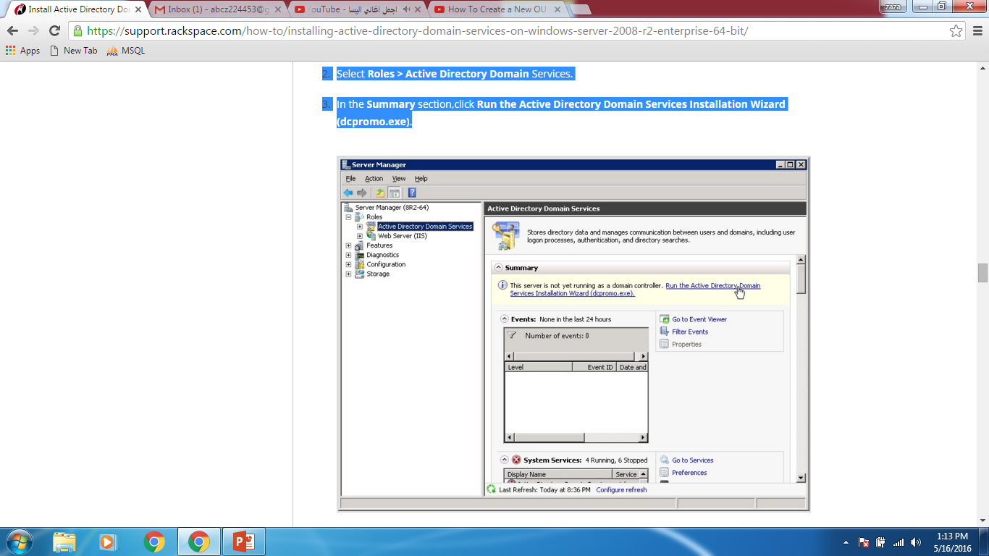

3. On the Welcome page of the Active Directory Domain Services Installation Wizard, ensure that the **Use advanced mode installation** check box is cleared, and then click **Next**.

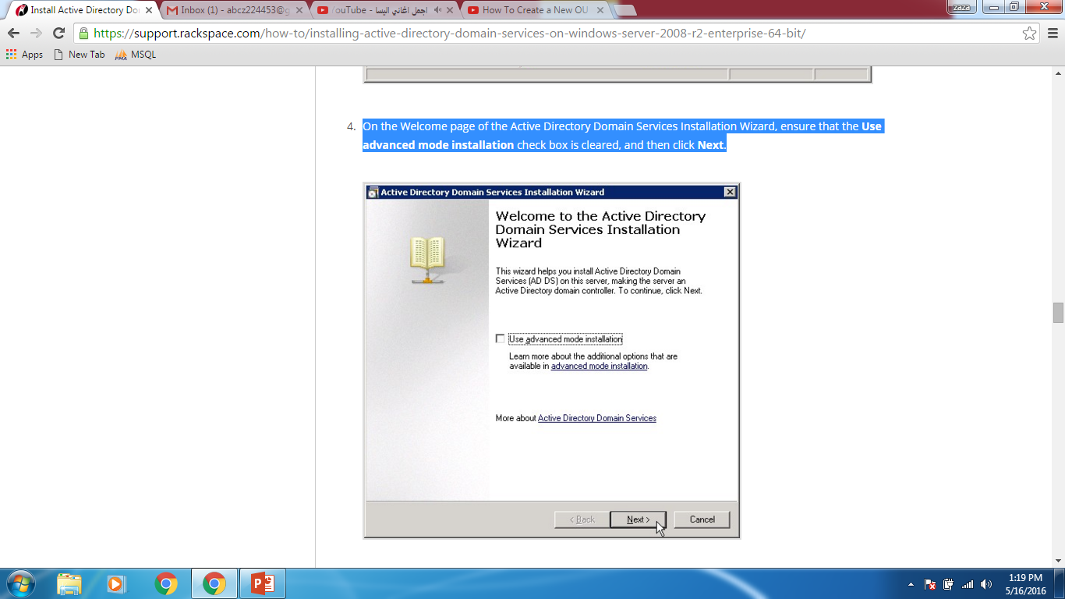

4. On the Operating System Capability page, click N**ext**.

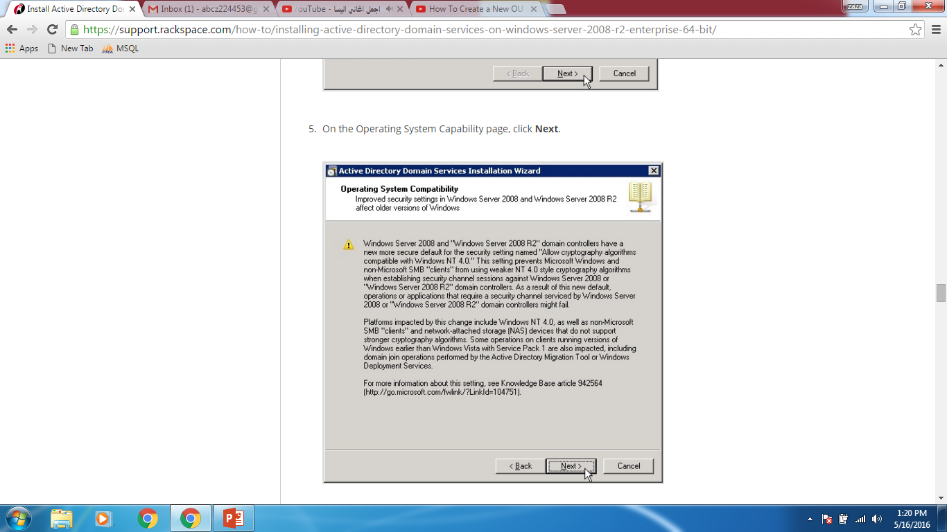

5. On the Choose a Deployment Configuration page, select **Create a new domain in a new forest** and then click **Next**.

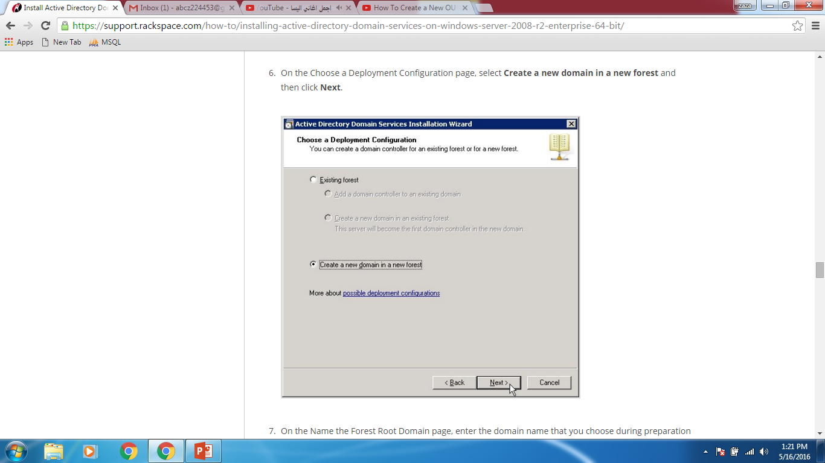

1. On the Name the Forest Root Domain page, enter the domain name that you choose during preparation steps. Then, click **Next**.

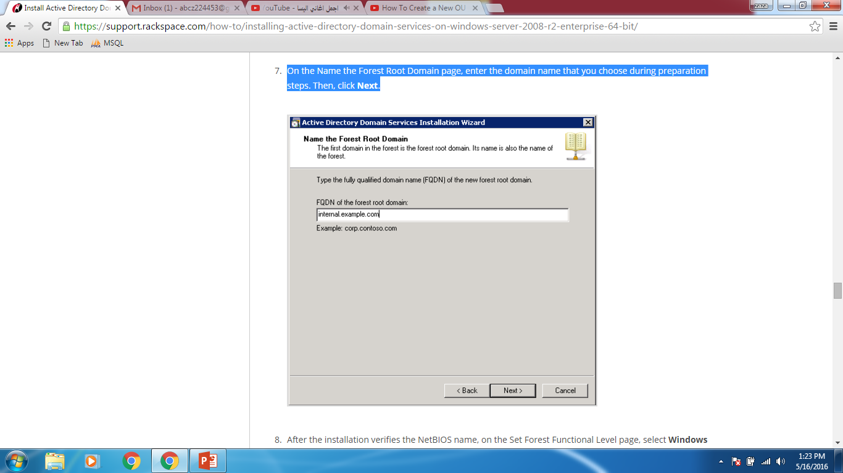

1. After the installation verifies the NetBIOS name, on the Set Forest Functional Level page, select **Windows Server 2008 R2** in the **Forest function level** list. Then, click **Next**.

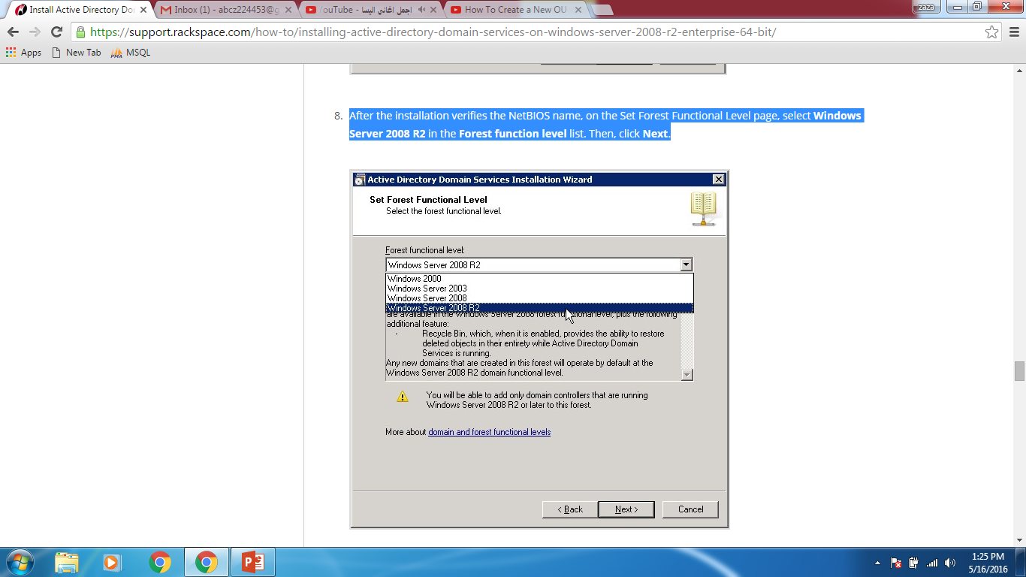

7. After the installation verifies the NetBIOS name, on the Set Forest Functional Level page, select **Windows Server 2008 R2** in the **Forest function level** list. Then, click **Next**.



The installation examines and verifies your DNS setting.  
8. On the Additional Domain Controller Options page, ensure that the **DNS server** check box is selected, and then click **Next**.

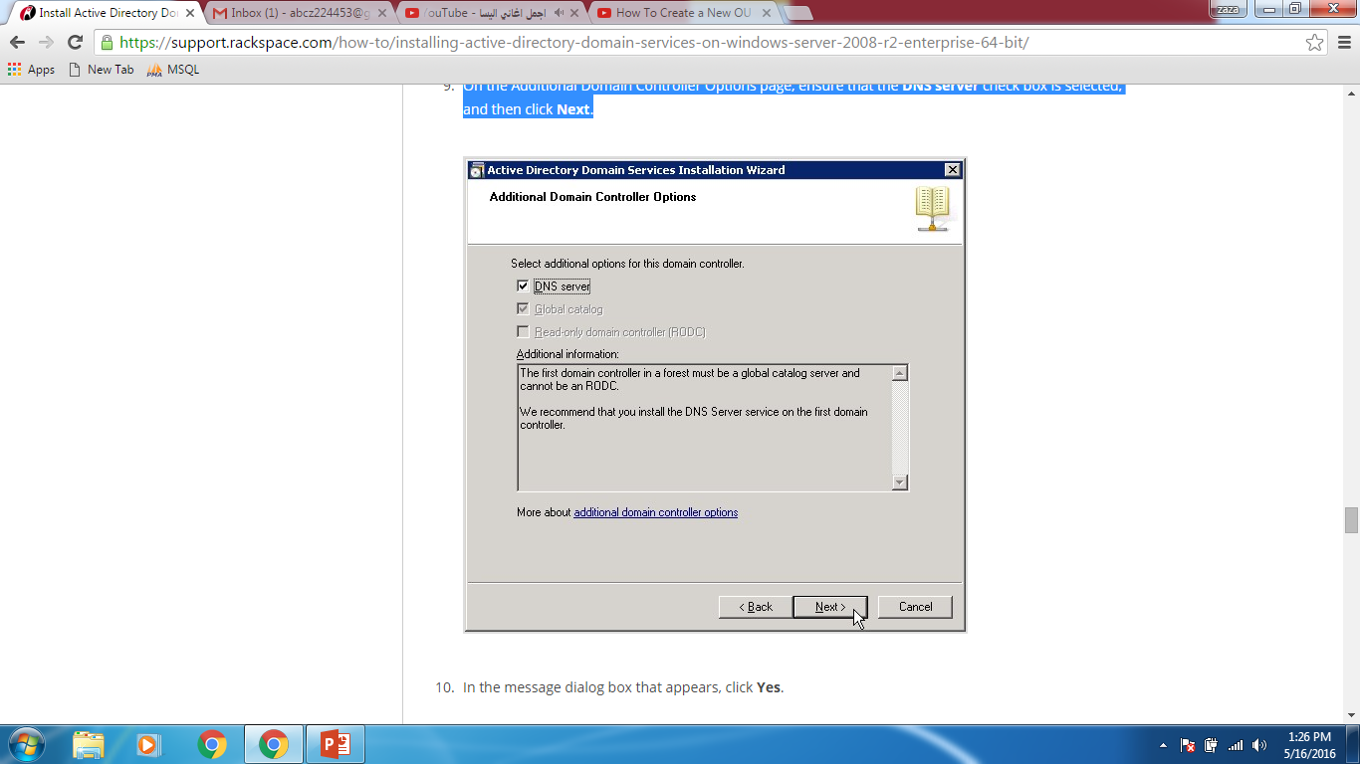

1. In the message dialog box that appears, click **Yes**

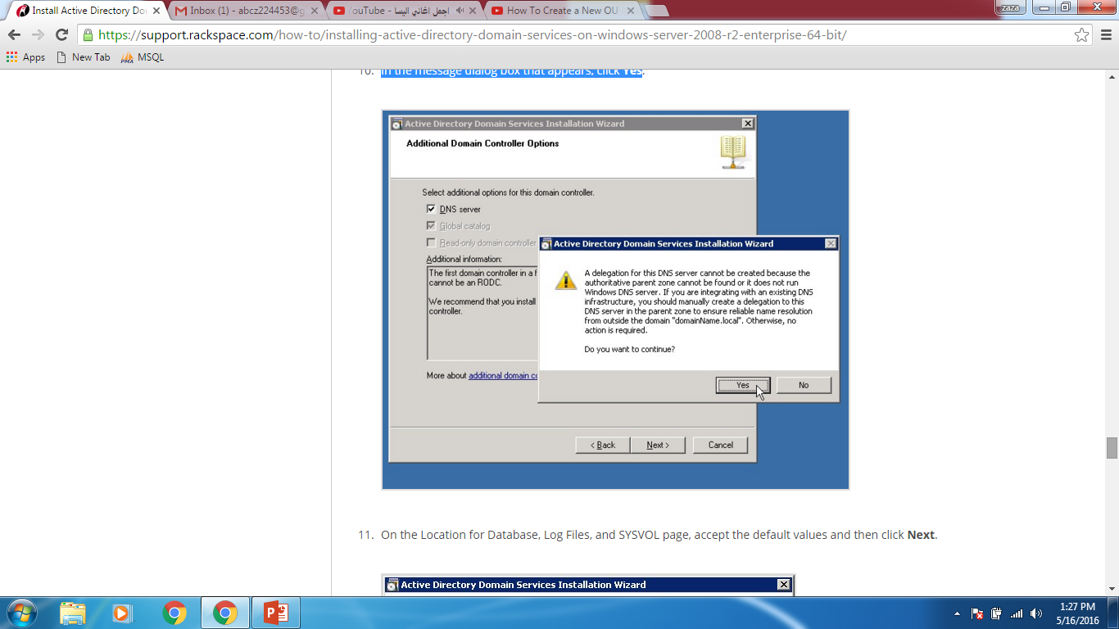

1. On the Location for Database, Log Files, and SYSVOL page, accept the default values and then click **Next**.

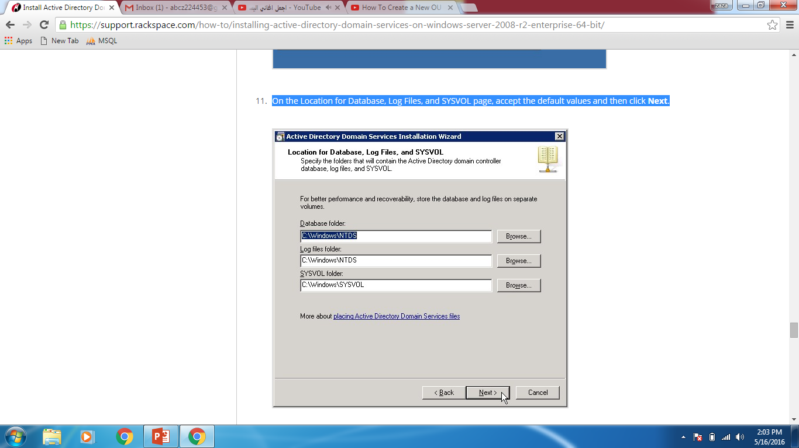

1. On the Directory Services Restore Mode Administrator Password page, enter the domain administrator password that you chose during the preparation steps. This is not your admin password that was emailed to you during the creation of your server, although you can use that password if you want to. Then, click **Next**

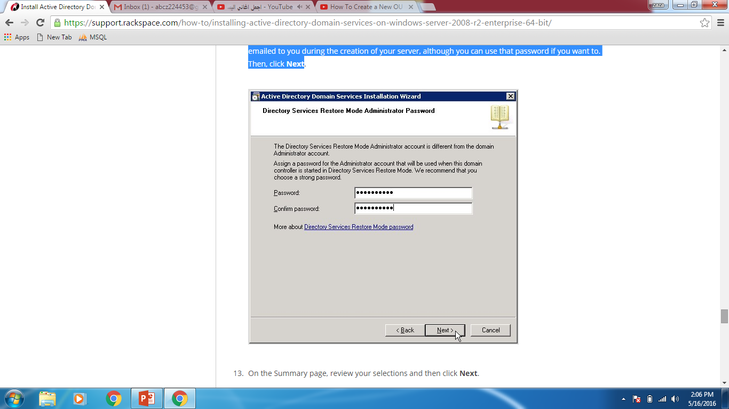

1. On the Summary page, review your selections and then click **Next  
   The installation begins**

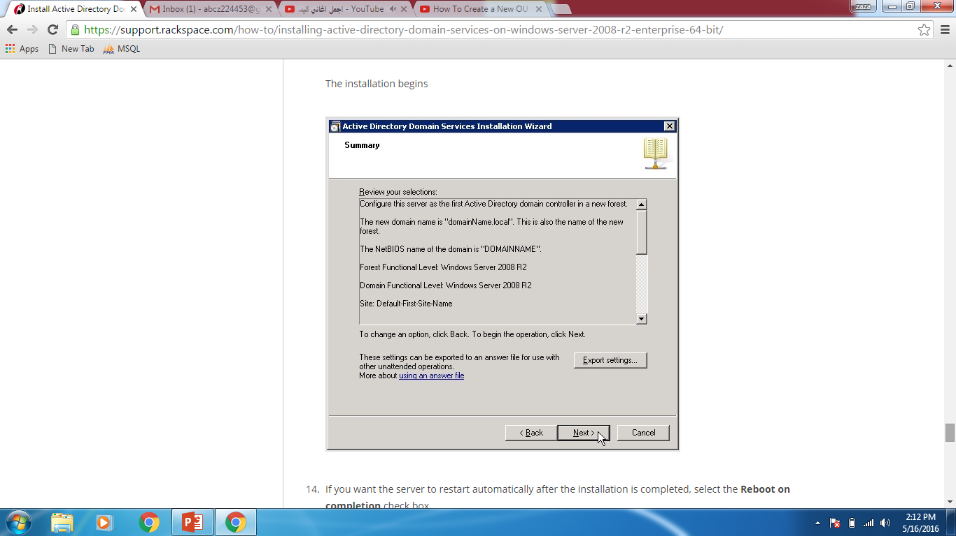

1. If you want the server to restart automatically after the installation is completed, select the **Reboot on completion** check box
2. If you did not select the **Reboot on completion** check box, click **Finish** in the wizard. Then, restart the server.

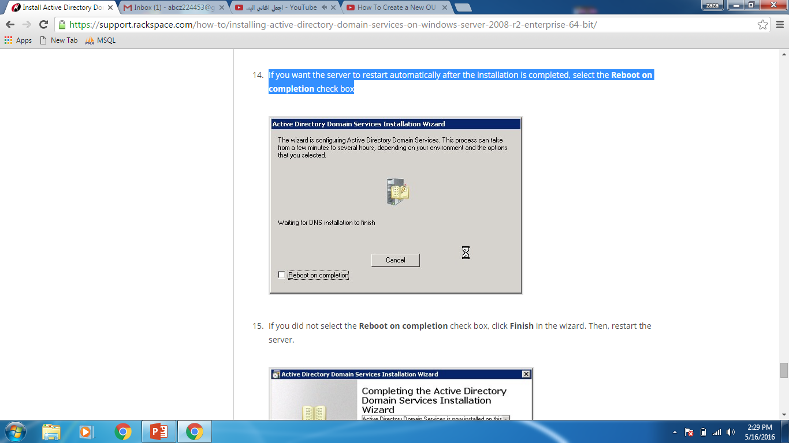

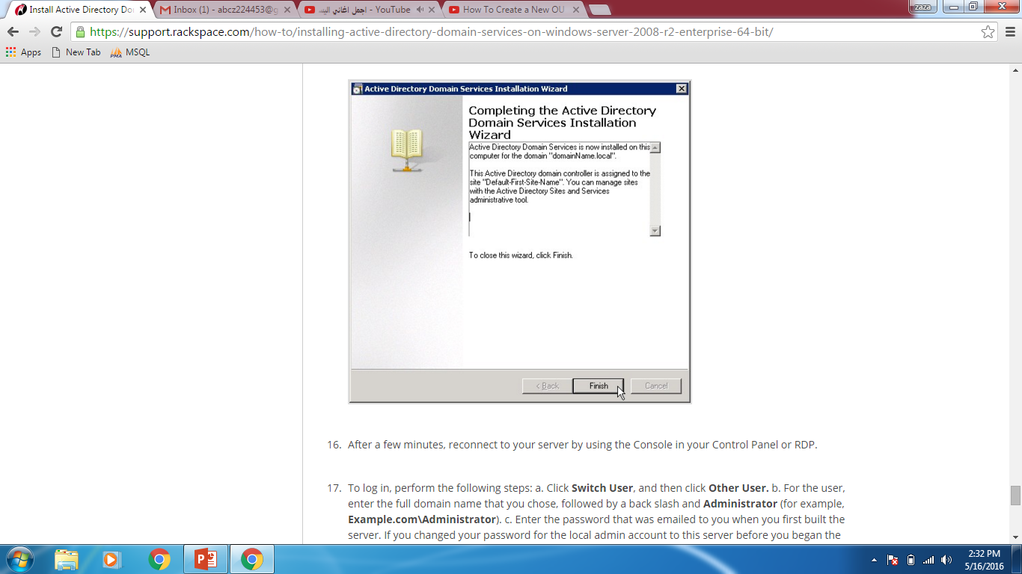

**To login,performe the following steps:**

**A**. Click **Switch User**, and then click **Other User.**

**B.** For the user, enter the full domain name that you chose, followed by a back slash and **Administrator** .

That is according to our domain enter : **INTERNAL\Administrator.**

**C.** Enter the **password** that was emailed to you when you first built the server.

If you change the password when you logged in, use the new one.

**D.** Click the log in button.

**So** the installation of **Active Directory Domain Services** on your server is complete.

Creating organization unit:

Go to active directory users and computers:

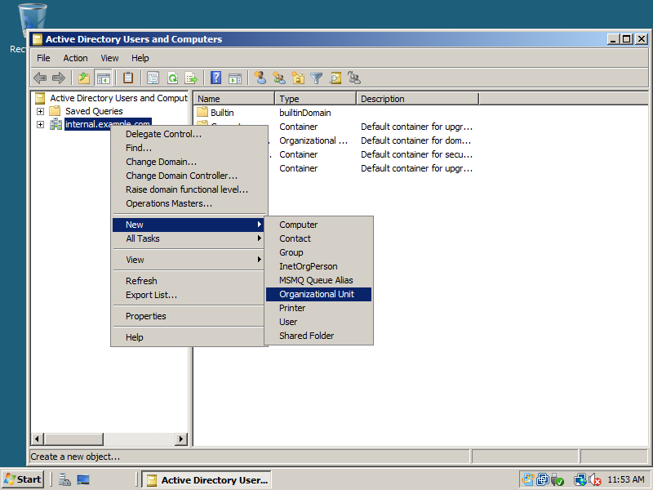

We creat two organization units (Administrator and limited user):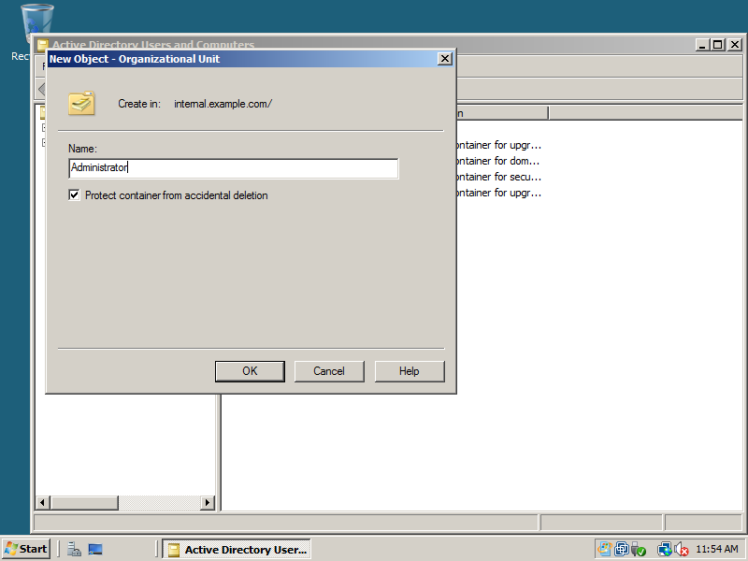

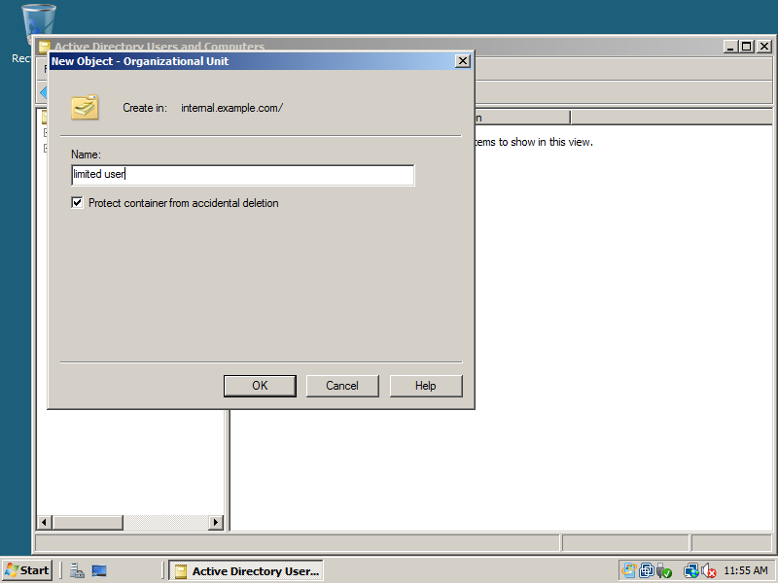

After that go to Administrative tools ->Group Policy Management , and create Group polidy object(named: Admin) and link it with Administrator organization unit.

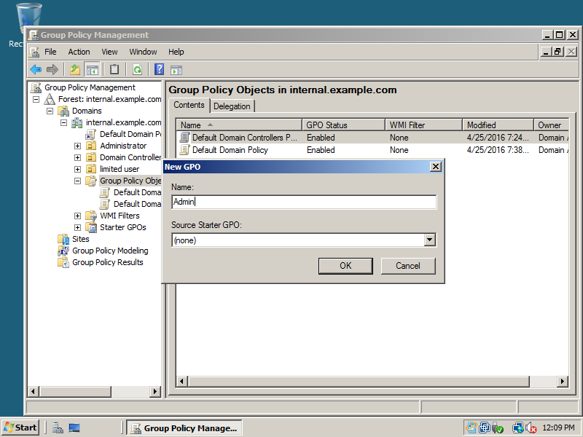

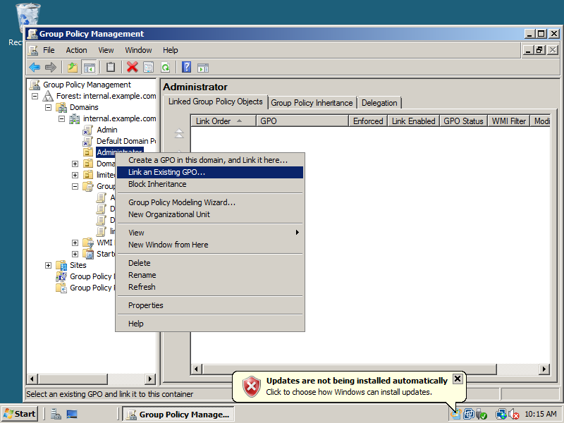

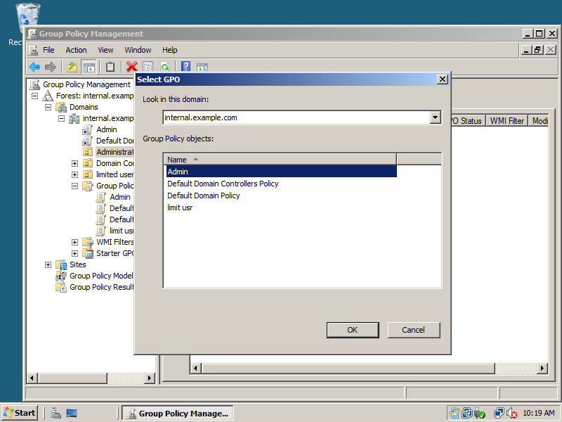

In the same way we create another GPO (named : limitusr) and we link it to limit user OU.

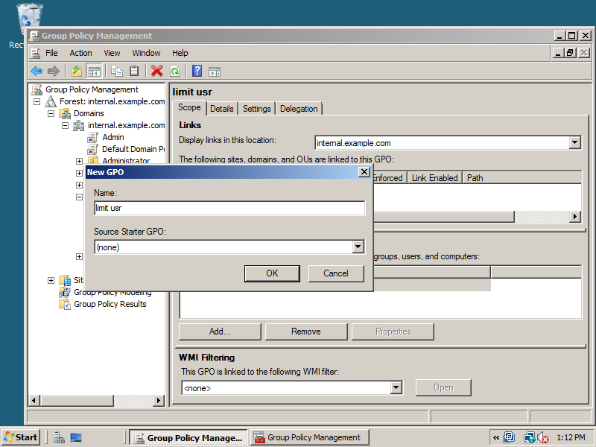

Now to disable cmd:

limit usr\edit\User Configuration\Administrative Templates\System

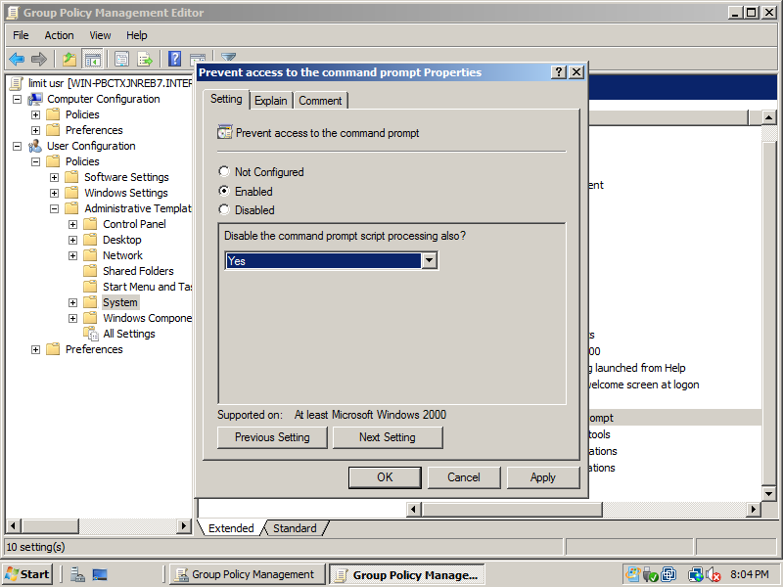

Now to disable right click:

User Configuration -> Administrative Templates -> Windows Components -> Windows Explorer -> Remove Windows Explorer's Default Context Menu

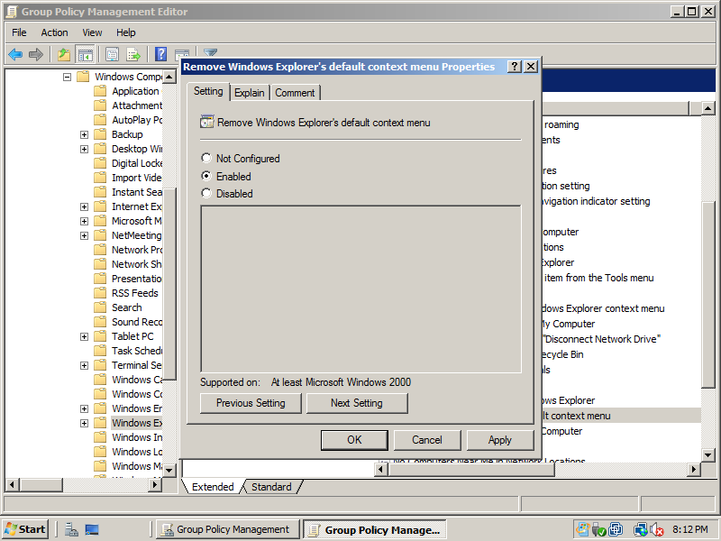

Now to disable install:

user Configuration > Administrative templates > Windows Components > Windows Installer>**Always install with elevated privileges**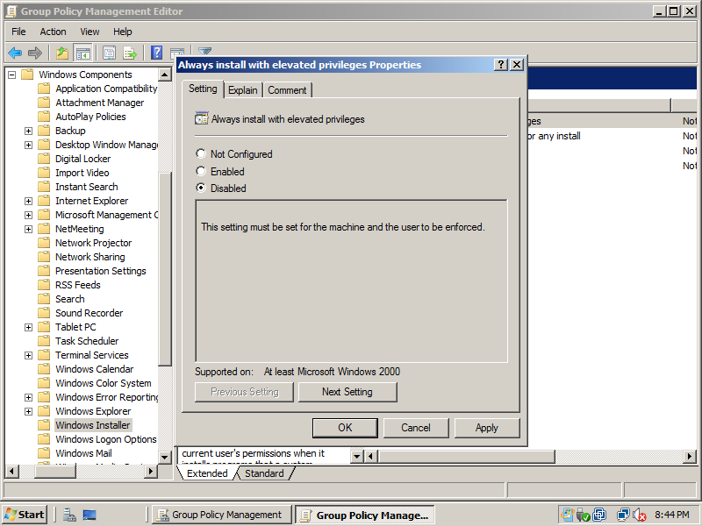

**Now we will create an user in each organization unit(OU)::**

**Go to the OU ->right lick->new->user**

**For OU Administrator we create user whose user name called zahraauser and for the other OU we call it kadiuser**

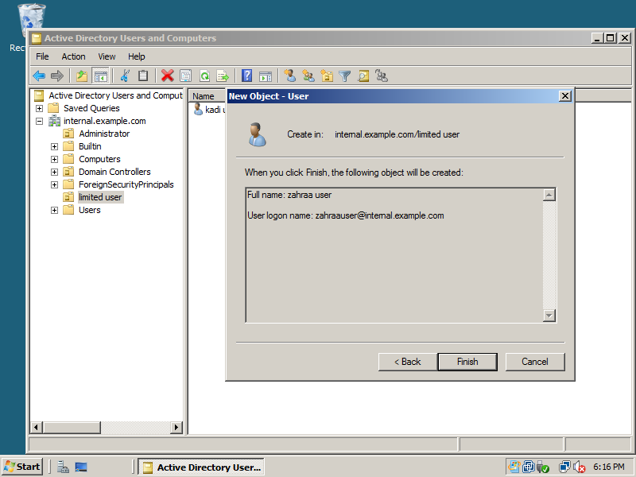

Now to Join Vmachines to domain : we set the VM settings (Network Adapter) as Custom and we and we adjust the two VMs on the lan (Vnet2)

**Connecting PC to Domain:**

Now to connect PC1(windows7) to the active directory domain :1-click start button select control panel -> system 2-click change setting and click PC name and after that click change add Pc description and domain name

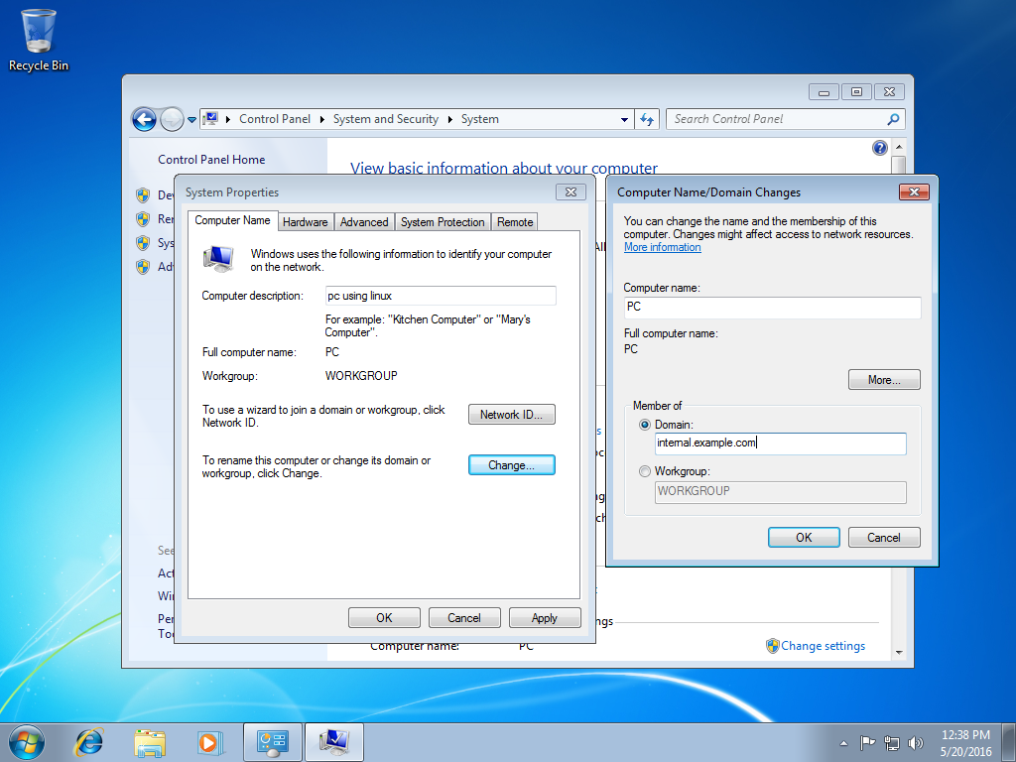

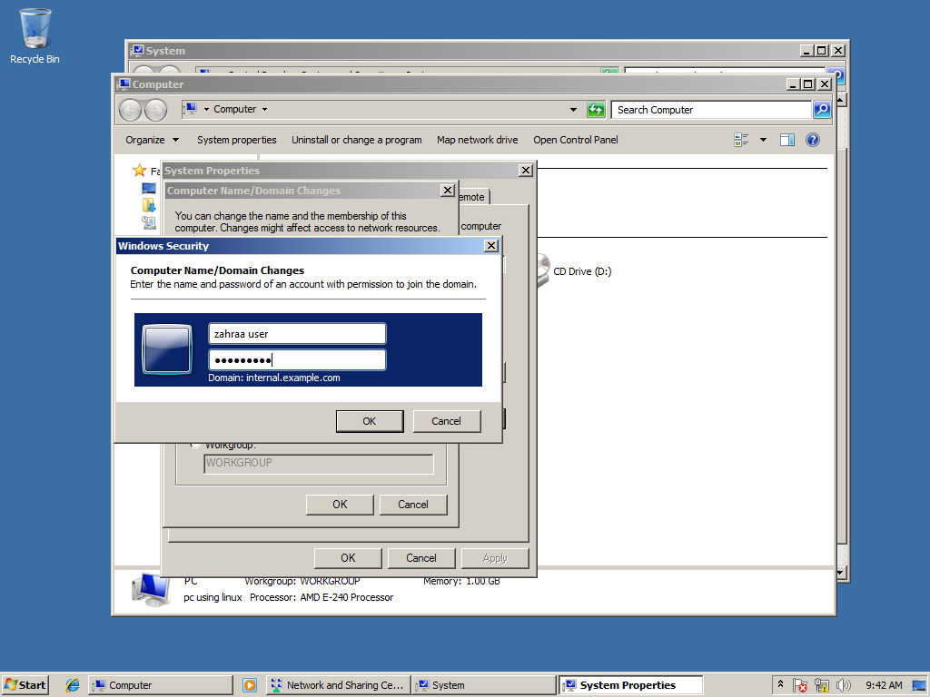

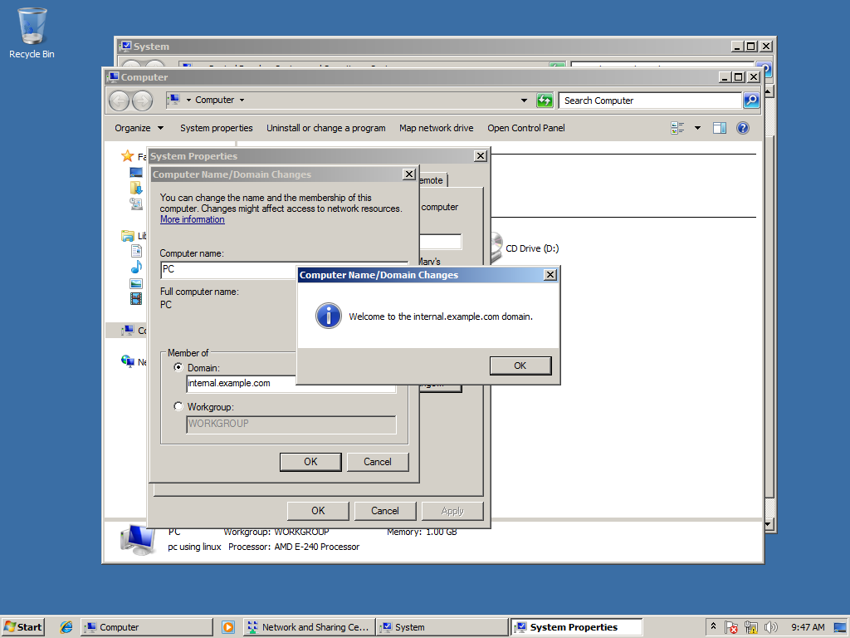

After doing all those steps Windows 7 VM is connected after entering the user name and password for my organizational units’ account and clicking ok then restarting the machine at the end.

And now we want to connect another PC to the second organization unit.

Now to connect the second PC which is windows 10 to the active directory domain ,we use the same way as we used it to connect pc1 to the domain which is CONTROL PANEL->SYSTEM->CHANGE SETTING ->CHANGE then we enter name of computer(PC2) and the domain(internal.example.com)->press OK. We get on our screen a notification to enter the user name and the password

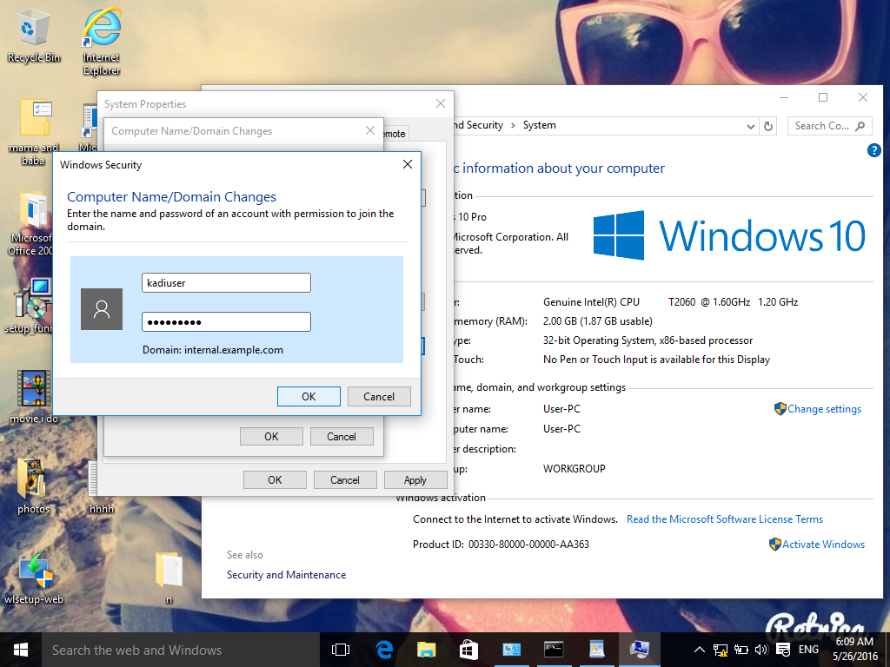

.AS a result ,it is done and the PC is connected to the domain.

